ECE322L - Lab 1

Circuit Simulation

Roger Holten, David Kirby, Landon Schmucker

**Goal**

Explore and gain understanding of Pspice and Multisim software.

**Software needed**

* PSpice and MultiSim

**The Lab**

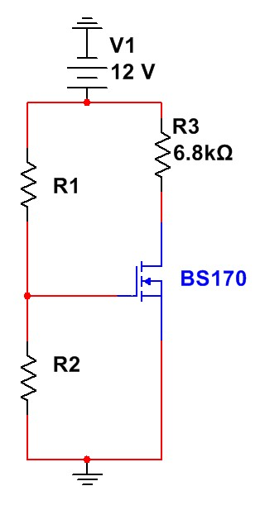

V

D

***Figure 1: Circuit Diagram.***

# Part 1 – Hand Calculations

Let K’n = 1.825 mA/v^2, (W/L) = 1, VTN = 1 V, and R1 + R2 = 100K. Bias the transistor such that half the supply voltage is across the transistor.

1. Find IDQ such that half the supply voltage is across the transistor
2. Find R1 and R2 through hand calculations.
3. Solve for VDSQ and VGSQ.

Use the following table to keep track of the measurements.

|  |  |  |  |
| --- | --- | --- | --- |
|  | Hand Calc | PSPICE | MultiSim |
| IDQ | 0.8824mA | 0.876mA | 0.876mA |
| VDSQ | 6V | 6.04V | 6.04V |
| VGSQ | 1.9833V | 1.98V | 1.98V |
| R1 | 83.472kΩ | N/A | N/A |
| R2 | 16.528kΩ | N/A | N/A |

## Part 2 – Modeling the Circuit in Pspice

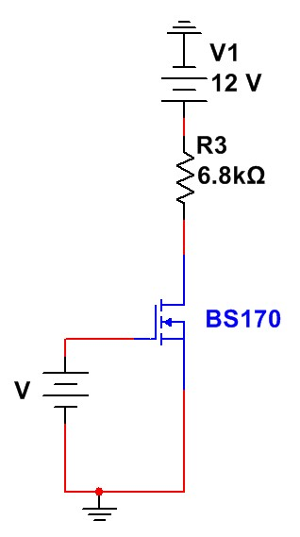

***Fig 2: PSPICE circuit diagram***

1. Create the circuit in PSPICE

1. Provide a graph with VD as a function of VG in your report.A screen shot of a computer

   Description automatically generated

## Part 3 - MultiSim

1. Created the circuit shown in figure 2.
2. In MultiSim we can place probes which can help with quick analysis and setting up simulations.

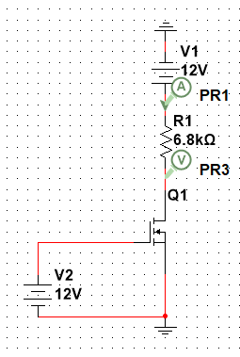

1. Compare the differences of the quiescent values obtained through PSPICE and hand calculations. What could cause the differences?

The differences between quiescent values of PSPICE and hand calculations is minimal and most likely just due to rounding in the PSPICE software. Another possible issue is in the PSPICE we only did steps of 0.01V for the DC Sweep which would cause the small rounding error.

1. Which simulation software do you prefer? Why? (not limited to Pspice and Multisim)

We personally prefer Pspice due to its ability to work with netlist and visual circuit creation. It also tends to be a little easier to do multiple simulations at once as you can just add them to the end of the netlist. It also is easier to edit the components since you can quickly change the netlist.